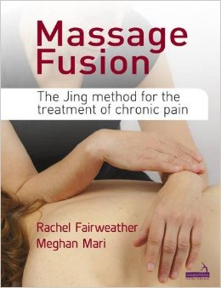
Contact: Nina Frizoni
Phone: 01273 628 942
Email: nina@jingmassage.com
http://bit.ly/1Kmwq1K

Empower your world with Massage Fusion

The Jing Method for Chronic Pain

“We are the music makers, and we are the dreamers of dreams.” – Roald Dahl

The UK’s award-winning massage training school, Jing Advanced Massage Training, is releasing its secrets to success in a groundbreaking new book – Massage Fusion.

Having already hit number 1 on the Amazon physiotherapy bestseller list, Massage Fusion offers a practical and human step-by-step approach to gaining results.

It focuses on persistent pain problem areas society typically suffers from today, such as lower back, neck, headaches, RSI, stress and stubborn sporting injuries.

World-renowned passionate and vibrant founders, Rachel Fairweather and Meghan Mari, inspire and encourage therapists by offering them a tried and tested blueprint for approaching chronic pain conditions with confidence.

When Jing Advanced Massage Training was founded in 2003 in a small front room, this electric duo took the UK massage world by storm by breaking down old boundaries and celebrating the rich dichotomy of art and science, East and West, and philosophy and psychology.

Now an innovative movement, having embraced 10,000 massage therapists around the world, Jing illustrates the magic in the fusion that happens when these worlds collide.

Training hundreds of therapists means that Jing has changed the lives of thousands of people, not only educating about clinical massage but equipping individuals to empower others to take control of their own healthcare. The Jing Method has become recognised as a viable treatment option for individuals worldwide in chronic pain. The result is a better quality of life for so many in ways nobody could ever have dreamed of.

Your body doesn’t have to define you, and your pain doesn’t have to control you.
It’s time for physical empowerment and freedom; it’s time to join the Jing revolution…

