# COSTS:

Pay Upfront: £6000

 -£500 (ends 31st Oct 24)

Payment Plan Total: £7000

£350 x 20

 -£250 (ends 31st Oct 24)

= £337.50 x 20)

Non-refundable deposit of £750 to book [Terms & conditions](https://www.jingmassage.com/terms-and-conditions-of-booking/)



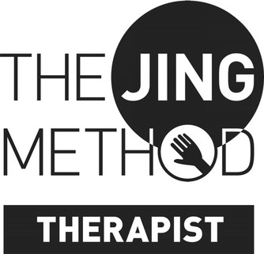

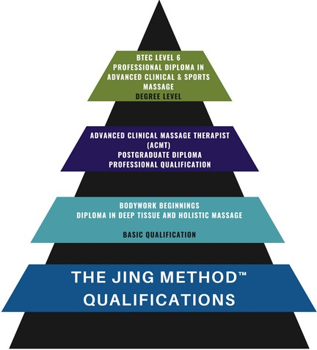

**TRACK FINISH DATE:** March 2027

Name:

Phone number:

Email:

How long have you been a qualified massage therapist?

3 things that excite you about completing the BTEC level 6:

1:

2:

3:

What formal education have you undertaken previously?

Have you ever written a paper of over 1000 words or more, if yes on what subject?

# COSTS:

Pay Upfront: £6000

 -£500 (ends 31st Oct 24)

Payment Plan Total: £7000

£350 x 20

 -£250 (ends 31st Oct 24)

= £337.50 x 20)

Non-refundable deposit of £750 to book [Terms & conditions](https://www.jingmassage.com/terms-and-conditions-of-booking/)







**TRACK FINISH DATE:** March 2027

Jing is open and supports all types of learners, do you have any special learning needs?

When you close your eyes and dream 5 years into the future - What does your massage practice look like?

Mixed media (online & hands-on) qualification.

For the dates see the education schedule.

Submit your application to info[@jingmassage.com](mailto:jemma@jingmassage.com)