Personal Details

Question: | Notes:
Are/could you be pregnant? Number of wks?
Allergies
DVT/blood clot risk
Infection/colds/fever in the last week?
Skin conditions
Any current medical conditions diagnosis’?

Are you currently taking any medication or supplements? If yes, how do they make you feel? Any noticeable side effects?

Are you currently under the care of any medical professionals/complementary health care practitioners? Details of treatment?

Full Name: |  | Date of 1st Treatment
Tel. No. |  | D.O.B.
Email: |  | Referral:
Emergency Contact: |  | Tel. No.
GP Information
GP Name/ Surgery |  | GP. Tel No.
GP Address: |  | Initial here if you give your consent for your therapist to contact your doctor’s surgery if they deem it necessary
Reason for seeking treatment

Health History
Type here

OPQRS

Type here

SMART Outcome
Type here

Any Additional Information

Type here

Have you ever had a professional massage before? Have you experienced The Jing Method before?

Type here

If yes, what did you like/dislike? (Pressure? Favourite areas to be massage? Any areas you dislike being touched?)

Type here

Observation
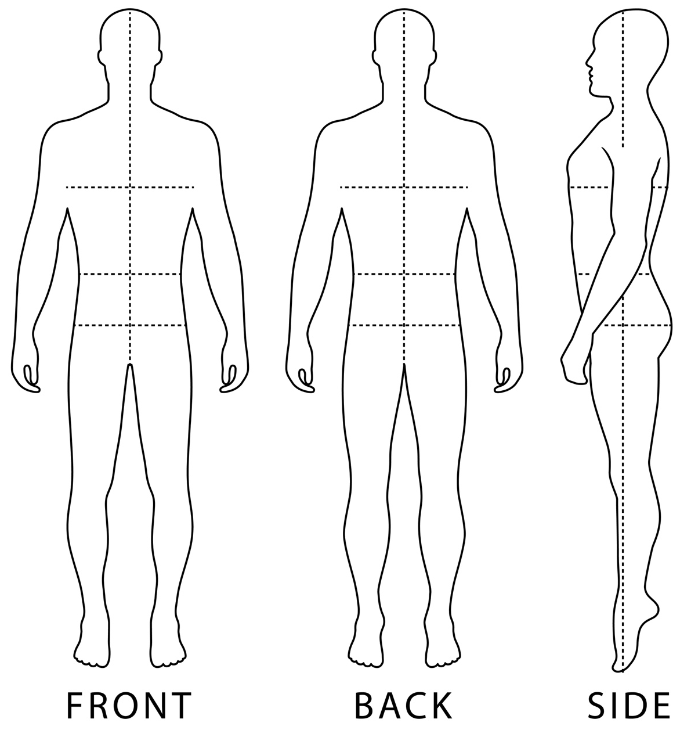

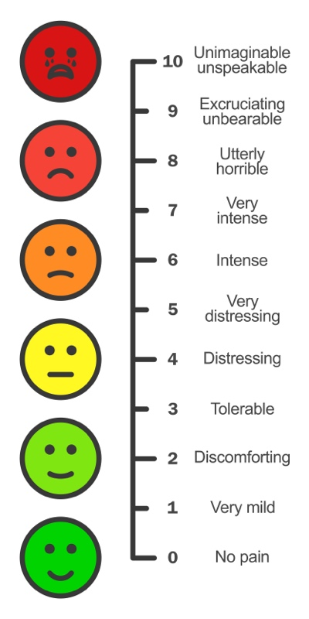

Observation Notes
Type here

ROM Assessment
Cervical Spine - CS
ACTION | MUSCLES INVOLVED | BEFORE TREATMENT |  |  |  | AFTER TREATMENT
 |  | P +/- | 1-10 | ROM |  | P +/- | 1-10 | ROM
Flex | SCM,  Ant. Scale
Extend | Up. Traps,  Lev. Scap,  Sub. Occ
ACTION | MUSCLES INVOLVED | BEFORE TREATMENT |  |  |  |  |  |  |  |  |  |  |  |  |  |  | AFTER TREATMENT
 |  | RIGHT |  |  |  |  |  |  |  | LEFT |  |  |  |  |  |  | RIGHT |  |  |  |  |  |  |  | LEFT
 |  | P +/- |  | 1-10 |  | ROM |  |  |  | P +/- |  | 1-10 |  | ROM |  |  | P +/- |  | 1-10 |  | ROM |  |  |  | P +/- |  | 1-10 |  | ROM
Lat  Flex | Up. Traps,  Lev. Scap,  SCM, Scalenes
Rot | Same Side:  Lev. Scap,  Spl cap & cer
Opp Side:
SCM,
Up Traps,
Scalenes
Shoulder – Glenohumeral Joint – GH
ACTION | MUSCLES INVOLVED |  | BEFORE TREATMENT |  |  |  |  |  |  |  |  |  |  |  |  |  |  | AFTER TREATMENT
 |  |  | RIGHT |  |  |  |  |  |  |  | LEFT |  |  |  |  |  |  | RIGHT |  |  |  |  |  |  |  | LEFT
 |  |  | P +/- |  | 1-10 |  | ROM |  |  |  | P +/- |  | 1-10 |  | ROM |  |  | P +/- |  | 1-10 |  | ROM |  |  |  | P +/- |  | 1-10 |  | ROM
Flex | Ant. Delt,  Up. Pec Maj,  Biceps Brac,  Coracobrach
Extend | Pos. Delt,  Lat dorsi,  Teres Maj,  Low. Pec Maj,  Triceps Brac
ABduct | Deltoid  Supraspinatus
ADduct | Lat. Dorsi,  Teres Maj,  Infraspinatus,  Pec. Maj
Ext/Lat Rot | Pos. Delt,  Infraspinatus,  Teres Min
Int/Med Rot | Ant. Delt,  Lat Dorsi,  Teres Maj,  Subscapularis,  Pec. Major

Shoulder – Glenohumeral Joint – GH
ACTION | MUSCLES INVOLVED | BEFORE TREATMENT |  |  |  |  |  |  |  |  |  |  |  |  |  |  |  | AFTER TREATMENT
 |  | RIGHT |  |  |  |  |  |  |  | LEFT |  |  |  |  |  |  |  | RIGHT |  |  |  |  |  |  |  | LEFT
 |  | P +/- |  | 1-10 |  | ROM |  |  |  | P +/- |  | 1-10 |  | ROM |  |  |  | P +/- |  | 1-10 |  | ROM |  |  |  | P +/- |  | 1-10 | ROM
H. Abd | Pos. Delt
H.Add | Ant. Delt  Up. Pec. Maj
Shoulder – Scapulothoracic Joint - ST
ACTION | MUSCLES INVOLVED | BEFORE TREATMENT |  |  |  |  |  |  |  |  |  |  |  |  |  |  |  | AFTER TREATMENT
 |  | RIGHT |  |  |  |  |  |  |  | LEFT |  |  |  |  |  |  |  | RIGHT |  |  |  |  |  |  |  | LEFT
 |  | P +/- |  | 1-10 |  | ROM |  |  |  | P +/- |  | 1-10 |  | ROM |  |  |  | P +/- |  | 1-10 |  | ROM |  |  |  | P +/- |  | 1-10 | ROM
Elevat | Up. Traps,  Rhomboids,  Lev. Scap.
Depres | Low. Traps,  Serratus Ant,  Pec. Minor
Abduct/ Protract | Serratus Ant,  Pec. Minor
Adduct/ Retract | Mid. Traps,  Rhomboids
Elbow – Humeroulnar & Humeroradial Joints
ACTION | MUSCLES INVOLVED |  | BEFORE TREATMENT |  |  |  |  |  |  |  |  |  |  |  |  |  |  |  | AFTER TREATMENT
 |  |  | RIGHT |  |  |  |  |  |  |  | LEFT |  |  |  |  |  |  |  | RIGHT |  |  |  |  |  |  |  | LEFT
 |  |  | P +/- |  | 1-10 |  | ROM |  |  |  | P +/- |  | 1-10 |  |  | ROM |  |  | P +/- |  | 1-10 |  | ROM |  |  |  | P +/- | 1-10 | ROM
Flex | Biceps Brac,  Brachialis,  Brachioradialis
Ext | Triceps Brac

Forearm – Proximal & Distal Radioulnar Joints
ACTION | MUSCLES INVOLVED | BEFORE TREATMENT |  |  |  |  |  |  |  | AFTER TREATMENT
 |  | RIGHT |  |  |  | LEFT |  |  |  | RIGHT |  |  |  | LEFT
 |  | P +/- | 1-10 | ROM |  | P +/- | 1-10 | ROM |  | P +/- | 1-10 | ROM |  | P +/- | 1-10 | ROM
Sup. | Pronat. Teres,  Pronat. Quad
Pron. | Biceps Brac,  Supinator,

Wrist – Radiocarpal Joints
ACTION | MUSCLES INVOLVED | BEFORE TREATMENT |  |  |  |  |  |  |  | AFTER TREATMENT
 |  | RIGHT |  |  |  | LEFT |  |  |  | RIGHT |  |  |  | LEFT
 |  | P +/- | 1-10 | ROM |  | P +/- | 1-10 | ROM |  | P +/- | 1-10 | ROM |  | P +/- | 1-10 | ROM
Flex. | Wrist  Flexors
Ext. | Wrist Extensors
Abduct/ Rad Dev | Ext. Car. Rads,  Ext. Polls,  Flex Car. Rad  Abd Poll Lon
Adduct/ Uln Dev | Ext Car Uln,  Flex Car Uln
Back - Vertebral Column
ACTION | MUSCLES INVOLVED | BEFORE TREATMENT |  |  |  | AFTER TREATMENT
 |  | P +/- | 1-10 | ROM |  | P +/- | 1-10 | ROM
Flex | Rec Abdom,  Ext Obliq,  Int Obliq  Psoas,  Iliacus
Ext | Erector Spin,  Rotatores,  Mulitifidi
ACTION | MUSCLES INVOLVED | BEFORE TREATMENT |  |  |  |  |  |  | AFTER TREATMENT
 |  | RIGHT |  |  |  | LEFT |  |  | RIGHT |  |  |  | LEFT
 |  | P +/- | 1-10 | ROM |  | P +/- | 1-10 | ROM | P +/- | 1-10 | ROM |  | P +/- | 1-10 | ROM
Lat  Flex | Iliocostalis,  Ext Oblique,  Int Oblique,  Longissimus,  QL
Rot | Same Side:  Ext Oblique,  Int Oblique,  Multifidi  Rotatores
Opp Side:
Ext Oblique,
Int Oblique,
Multifidi
Rotatores

Hip – Coxal Joint
ACTION | MUSCLES INVOLVED | BEFORE TREATMENT |  |  |  |  |  |  |  |  | AFTER TREATMENT
 |  | RIGHT |  |  |  | LEFT |  |  |  |  | RIGHT |  |  |  |  |  |  |  | LEFT
 |  | P +/- | 1-10 | ROM |  | P +/- | 1-10 |  | ROM |  | P +/- |  | 1-10 |  | ROM |  |  |  | P +/- |  | 1-10 |  | ROM
Flex | Psoas,  Iliacus, TFL,  Sartorius,  Rec Fem,  Ant Glut Med, Glute Min
Extend | Glute Max,  Hamstrings,  Pos Add Mag,  Pos Glut Med
ABduct | Glute Max,  Glute Med,  Glute Min,  TFL
ADduct | Add Magnus,  Add Long,  Add Brevis,  Pectineus,  Gracilis,  Low Glut Max
Ext/Lat Rot | Glute Max  Piriformis,  Quad Fem,  Ob int & ext,  Gem S & I,  Pos Glut Med,  Psoas, Iliacus
Int/Med Rot | Ant Glut Med,  Glute Min,  TFL,  Adductors
Knee – Tibiofemoral Joint
ACTION | MUSCLES INVOLVED | BEFORE TREATMENT |  |  |  |  |  |  |  | AFTER TREATMENT
 |  | RIGHT |  |  |  | LEFT |  |  |  | RIGHT |  |  |  |  |  |  |  | LEFT
 |  | P +/- | 1-10 | ROM |  | P +/- | 1-10 | ROM |  | P +/- |  | 1-10 |  | ROM |  |  |  | P +/- |  | 1-10 |  | ROM
Flex. | Hamstrings,  Gracilis,  Sartorius,  Gastroc,  Popliteus
Extend. | Quadriceps
Ext Rot (flexed) | Biceps Fem
Int Rot (flexed) | Semiten,  Semimem,  Gracilis,  Sartorius,  Popliteus

Ankle – Talocrural Joint
ACTION | MUSCLES INVOLVED | BEFORE TREATMENT |  |  |  |  |  |  |  | AFTER TREATMENT
 |  | RIGHT |  |  |  | LEFT |  |  |  | RIGHT |  |  |  | LEFT
 |  | P +/- | 1-10 | ROM |  | P +/- | 1-10 | ROM |  | P +/- | 1-10 | ROM |  | P +/- | 1-10 | ROM
Plantar  Flex | Gastroc,  Soleus,  Tib Post,
Dorsi  Flex | Tib Ant,  Ext Dig Long,  Ext Hall Long
Foot – Talotarsal, Midtarsal & Talometatarsal Joints
ACTION | MUSCLES INVOLVED | BEFORE TREATMENT |  |  |  |  |  |  |  | AFTER TREATMENT
 |  | RIGHT |  |  |  | LEFT |  |  |  | RIGHT |  |  |  | LEFT
 |  | P +/- | 1-10 | ROM |  | P +/- | 1-10 | ROM |  | P +/- | 1-10 | ROM |  | P +/- | 1-10 | ROM
Evers | Peroneals,  Ext Dig Long
Invers | Tib Ant,  Tib Post,  Flex Dig Long,  Flex Hal Long,  Ext Hal Long

- Acute / Subacute/ Chronic | - Structures Involved: bone, joint, muscle, tendon, ligament, nerves
- Muscles Potentially Involved: based on: ROM agonist/antagonist; TP pain patterns; pathology | - Postural holding patterns / compensation
- Possible pathology / Any suggested professional referral | - Red / Yellow flags
- Central Nervous System: stress; anxiety; central sensitisation | - Client personality / outlook (biopsychosocial)
Type here

Clinical Assessment Summary

Informed Consent and GDPR

Informed Consent:
- I have had a thorough consultation with my chosen practitioner
- I have been informed of the proposed treatment plan and agree to proceed with my therapist to address my specific needs.
- I understand that therapeutic massage is not a substitute for traditional medical treatment.
- I understand the importance of informing my massage therapist of all medical conditions and medications I am taking, and to let the massage therapist know about any changes to these. I understand that there may be additional considerations based on my physical/emotional/psychological condition.
- I understand that it is my responsibility to inform my massage therapist of any discomfort I may feel during the massage session so he/she may adjust accordingly.

Client Signature |  | Date:
Therapist Signature |  | Date:
I would love to sign up to your newsletter and be contacted with all your practice updates

GDPR May 2018:
The data collected on this form will be used for the sole purpose of clinical massage and will not be disclosed to any external sources. For insurance purposes these records shall be kept for at least 7 years following the last occasion on which treatment was given.

Treatment Notes

SMART Outcome:

Treatment Summary & Clinical Evaluation:

Plan for next treatment:

Self-care Advice/Online follow up appointment:

Client Feedback:

Date of Next Treatment:

Tx 1

Professional Reflective Notes
Type here

