Personal Details

Question: | Notes:
Are/could you be pregnant? Number of wks?
Allergies
DVT/blood clot risk
Infection/colds/fever in the last week?
Skin conditions
Any current medical conditions diagnosis’?

Are you currently taking any medication or supplements? If yes, how do they make you feel? Any noticeable side effects?

Are you currently under the care of any medical professionals/complementary health care practitioners? Details of treatment?

Full Name: |  | Date of 1st Treatment
Tel. No. |  | D.O.B.
Email: |  | Referral:
Emergency Contact: |  | Tel. No.
GP Information
GP Name/ Surgery |  | GP. Tel No.
GP Address: |  | Initial here if you give your consent for your therapist to contact your doctor’s surgery if they deem it necessary
Reason for seeking treatment

Health History
Type here

Desired Outcome

Type here

Massage Information
Have you ever had a professional massage before? Have you experienced The Jing Method before?

Type here

If yes, what did you like/dislike? (Pressure? Favourite areas to be massage? Any areas you dislike being touched?)

Type here

Any Additional Information
Type here

Observation
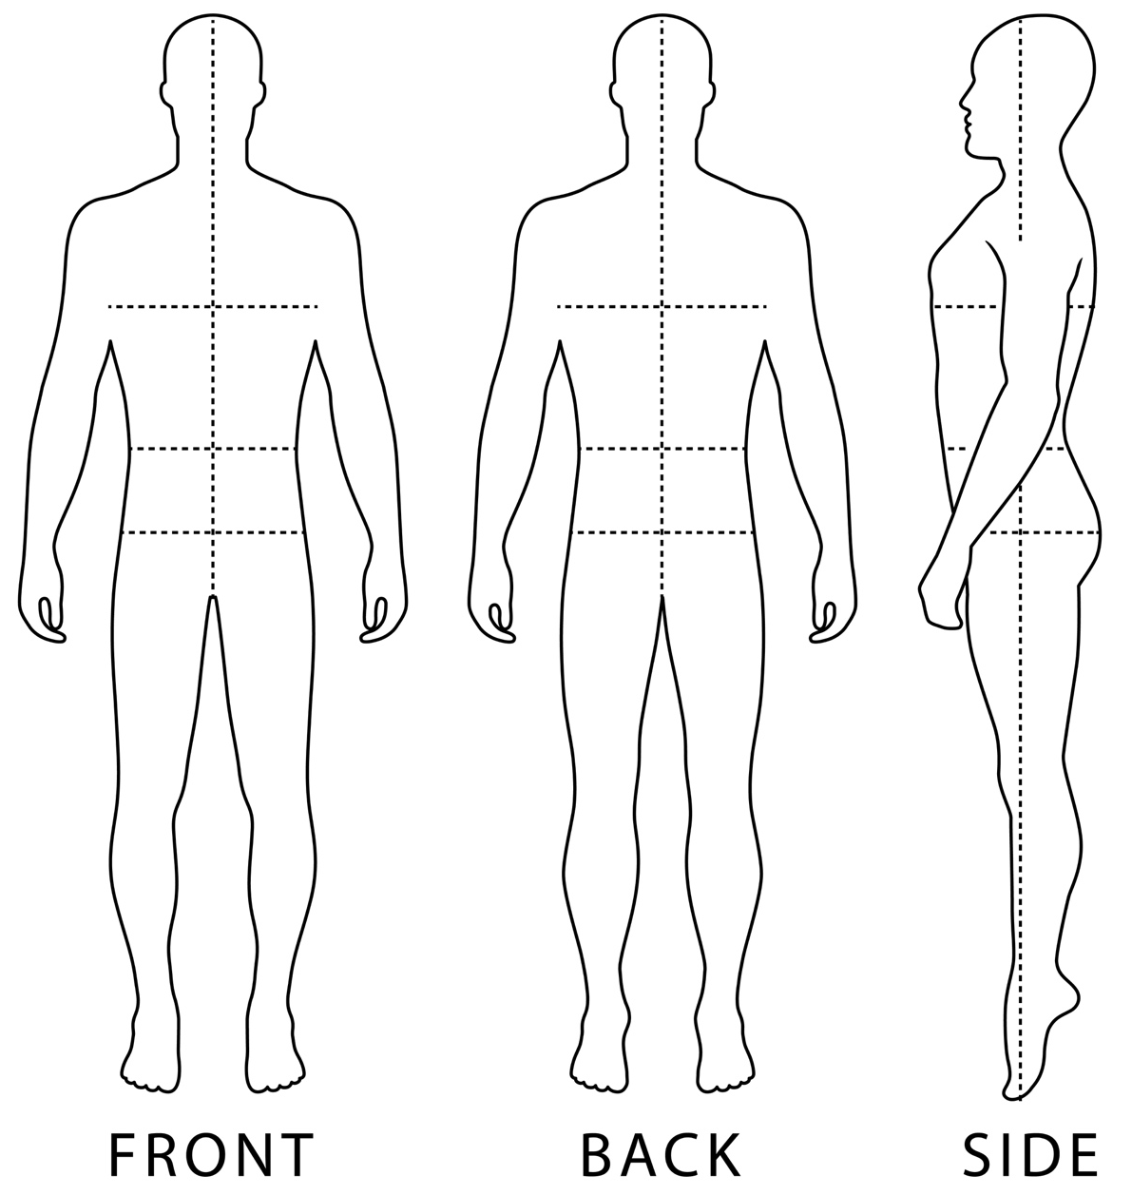

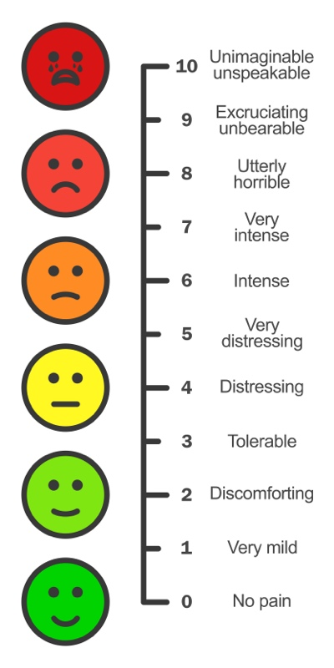

Observation Notes
Type here

Informed Consent and GDPR

Informed Consent:
- I have had a thorough consultation with my chosen practitioner
- I have been informed of the proposed treatment plan and agree to proceed with my therapist to address my specific needs.
- I understand that therapeutic massage is not a substitute for traditional medical treatment.
- I understand the importance of informing my massage therapist of all medical conditions and medications I am taking, and to let the massage therapist know about any changes to these. I understand that there may be additional considerations based on my physical/emotional/psychological condition.
- I understand that it is my responsibility to inform my massage therapist of any discomfort I may feel during the massage session so he/she may adjust accordingly.

Client Signature |  | Date:
Therapist Signature |  | Date:
I would love to sign up to your newsletter and be contacted with all your practice updates

GDPR May 2018:
The data collected on this form will be used for the sole purpose of clinical massage and will not be disclosed to any external sources. For insurance purposes these records shall be kept for at least 7 years following the last occasion on which treatment was given.

